**Sensor Characterization**

This is a summary of the sensor designs and their performance

Design #1

**Simple Inverting Amp**

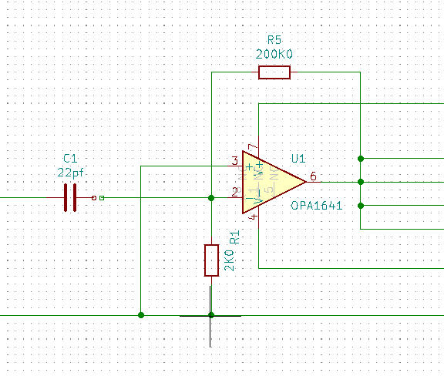

Figure 1: Simple Inverting Amp

This was the design used in Version 1.0X. The signal from the microphone is negative going on the leading edge, hence an inversion was done to flip the signal over and make it useable for the comparator on the circuit board.

Performance of this circuit was good, but very sensitive. Opening the air cylinder at 6 meters would trigger a detection. Moving the mouse on a table nearby would also generate a trip. Clearly too sensitive.

Design #2

**Classical Inverting Amplifier**

The pull down resistor was moved to be a series resistor, and set to 0Ohms. The 2K pull up resistor attached to the microphone acts as the current limit for the amplifier feedback

No apparent change in the sensitivity. Pulling trigger (click) would be detected at 6m.

Design #3

**Feedback set to 47K0 Ohms**

Does not detect trigger click at 6m, but does detect snapped fingers at about 1/2m

Does not detect mouse clicks on the table.

Setting threshold to 1V, all sensors detect snapped fingers.